**Steps to Integrate New Relic SDK with Android Application.**

**Credentials** :- UserName :- [hd00483723@techmahindra.com](mailto:hd00483723@techmahindra.com)

Password :- Techm_2018

1. **Add New Relic to Project Build.**

* Merge the following into project-level **build.gradle**file:

apply **plugin**: **'newrelic'**

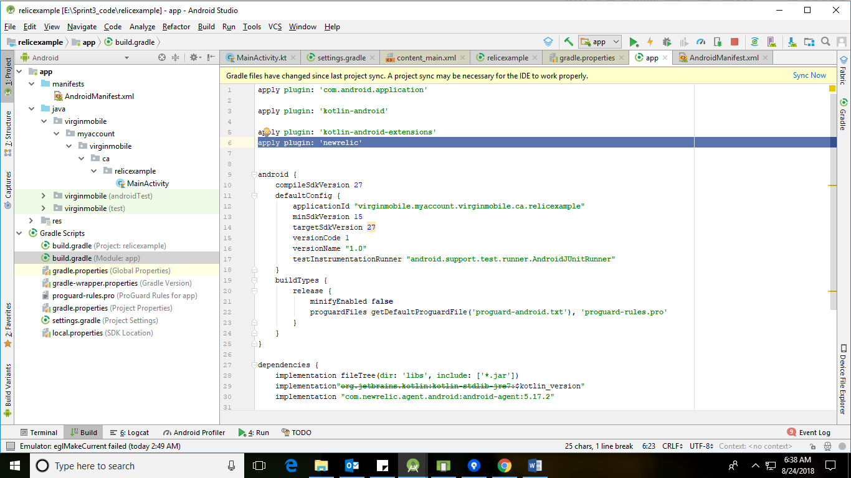

**Add below line in dependencies**

implementation **"com.newrelic.agent.android:android-agent:5.17.2"**

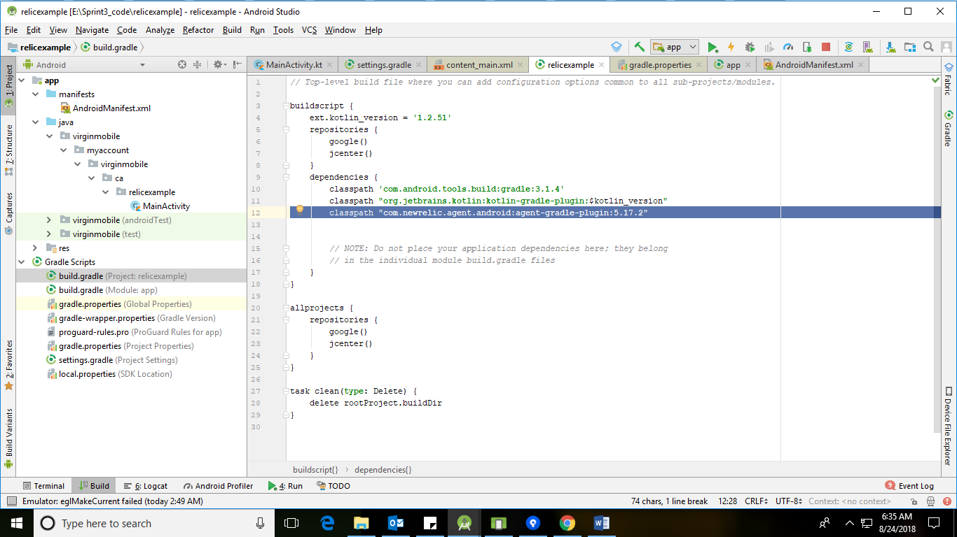

* Merge the following into app-level **build.gradle**file:

**implementation "com.newrelic.agent.android:android-agent:5.17.2"**

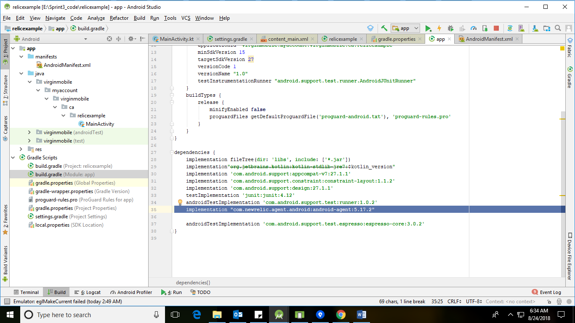

1. **SetUp Permission in Android menifest File.**

Ensure that app requests INTERNET and ACCESS_NETWORK_STATE permissions by adding below lines to Application AndroidManifest.xml.

<**uses-permission android:name="android.permission.INTERNET"** />

<**uses-permission android:name="android.permission.ACCESS_NETWORK_STATE"** />

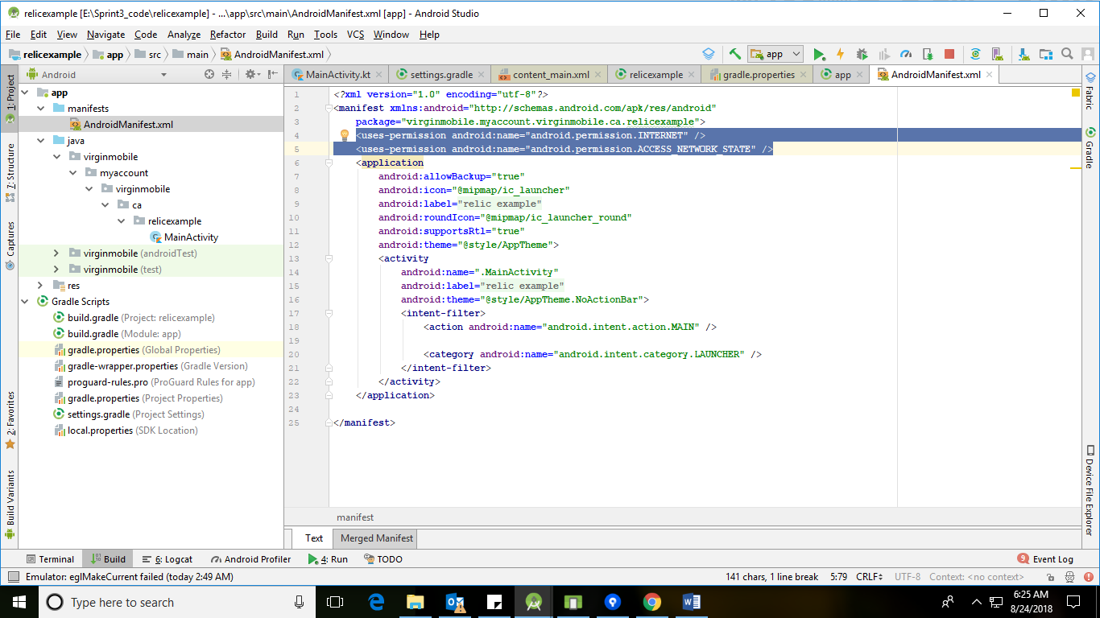

1. **Start the New Relic Agent for Android**

Import NewRelic class in Application’s Default

**Import com.newrelic.agent.android.NewRelic;**

In the **onCreate()** method add below call to initialize New Relic.

 (The unique token included below has been generated for MVM App specifically)

**NewRelic.withApplicationToken(  
 "AA14afc87cf30b687b0acf96f3007112ea7c7db07c"  
 ).start(this.getApplication());**

**Note**:- Please add above line in the start of OnCreate() method

MVM Unique token :- **"AA14afc87cf30b687b0acf96f3007112ea7c7db07c".**

**Generated by NewRelic agent automatically at the time of setup in NewRelic Website.**

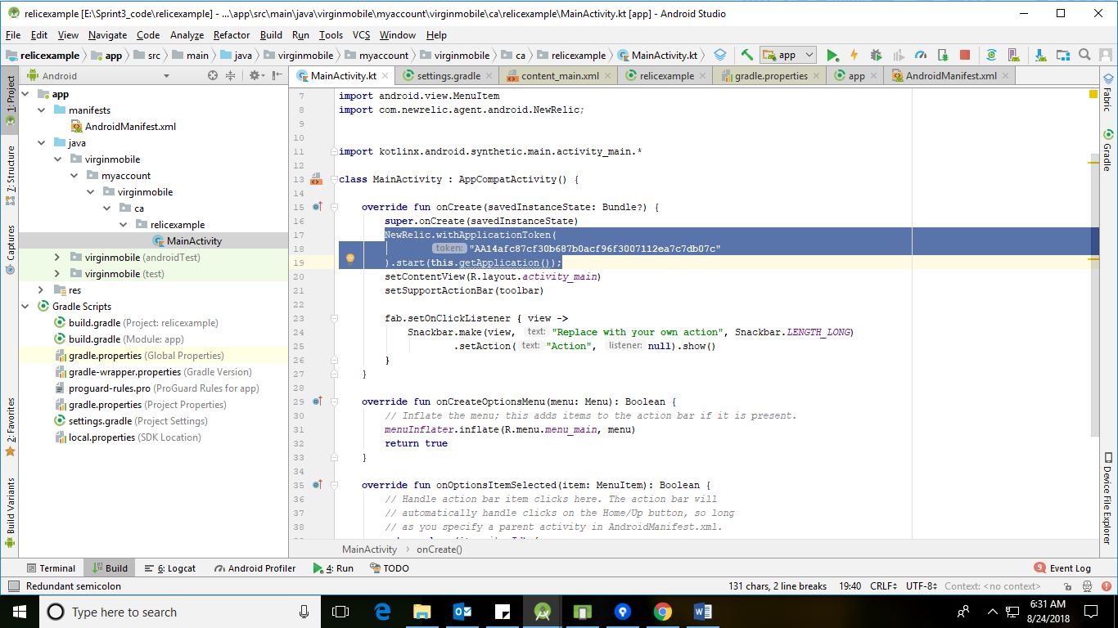

1. **Build and Run Application.**

Clean project and then run app in an emulator or device to start seeing data.

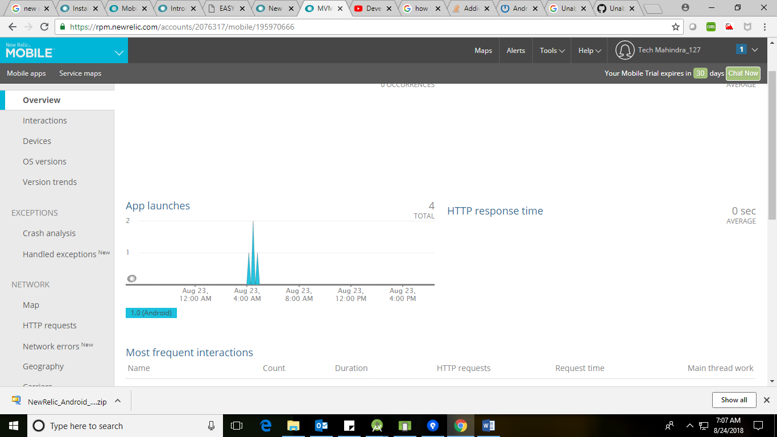

We can see data of Application in New Relic Dashboard.